**OUTPUT:**

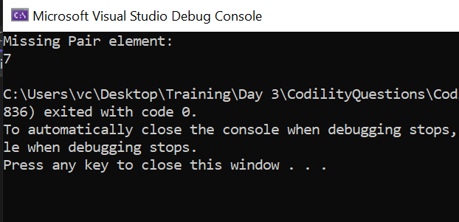

**CODE:**

using System;

using System.Collections.Generic;

using System.Linq;

using System.Text;

using System.Threading.Tasks;

namespace CodilityQuestions

{

internal class Program2

{

static void Main(string[] args)

{

int[] arr = { 9, 3, 9, 3, 9, 7, 9 };

int bitxor=0;

for(int i = 0; i < arr.Length; i++)

{

bitxor ^= arr[i];

}

Console.WriteLine("Missing Pair element:");

Console.WriteLine(bitxor);

}

}

}